Alkaloid production in Catharanthus roseus cell cultures elicited with cyclodextrins and methyljasmonate
L. Almagro*, A.B. Sabater-Jara, S. Belchí-Navarro, A.J. López-Pérez, M. Sotomayor, and M.A. Pedreño.
Department of Plant Biology. University of Murcia. Murcia. Spain.
* Corresponding author, e-mail: lorena.almagro@um.es

Topic: System engineering approach

Abstract: Catharanthus roseus produces numerous alkaloids with high pharmaceutical importance such as vinblastine and vincristine which have antineoplastic activity. Because these dimeric alkaloids are produced at very low levels in plants, Catharanthus roseus cell cultures have been studied for many years as a potential way to produce these compounds as well as the monomers vindoline, catharanthine and ajmalicine. However, despite the extensive studies on the standardization of cell growth and the selection of high yielding cell lines, the alkaloid production from suspension cultures is relatively low. Among different strategies to increase alkaloid production, elicitation could be one efficient strategy to provoke important increases in product yield.
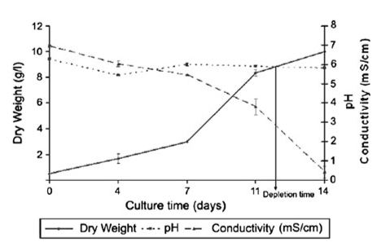
Fig.1 Sample figure: Please chose the line thickness, the symbol size and the lettering for clear appearance on the printed abstract.
Morales et al.¹ demonstrated that elicitation of grapevine cell cultures with cyclodextrins (CDs) induced the production of resveratrol, the stilbene unit characteristic from Vitaceae family. The effect of CDs on resveratrol production allowed the development of an innovative procedure where high levels of this metabolite were accumulated and were easily recovered directly from the culture media without cell biomass destruction². Moreover, the combined use of methyljasmonate (MeJA) and CDs provoked a synergistic effect increasing even more the levels of resveratrol in grapevine cell cultures (See Figure 1).
In the present research work, we tried to extrapolate this innovative technology focusing on alkaloid production improvement by elicitation of Catharanthus roseus cell cultures with a combination of both MeJA and CDs.

Acknowledgements: This s work was partially supported by ……….

References
1. M. Morales, R. Bru, F. García-Carmona, A. Ros Barceló , M.A. Pedreño. Plant Cell Tiss. Org., 1988, 53, 179-187.
2. L. Almagro, A.J. Lopez Perez, M.A. Pedreno, Biotechnol. Lett. 2011, 33, 381-385

